**Ramadan Date Cookie Recipe**

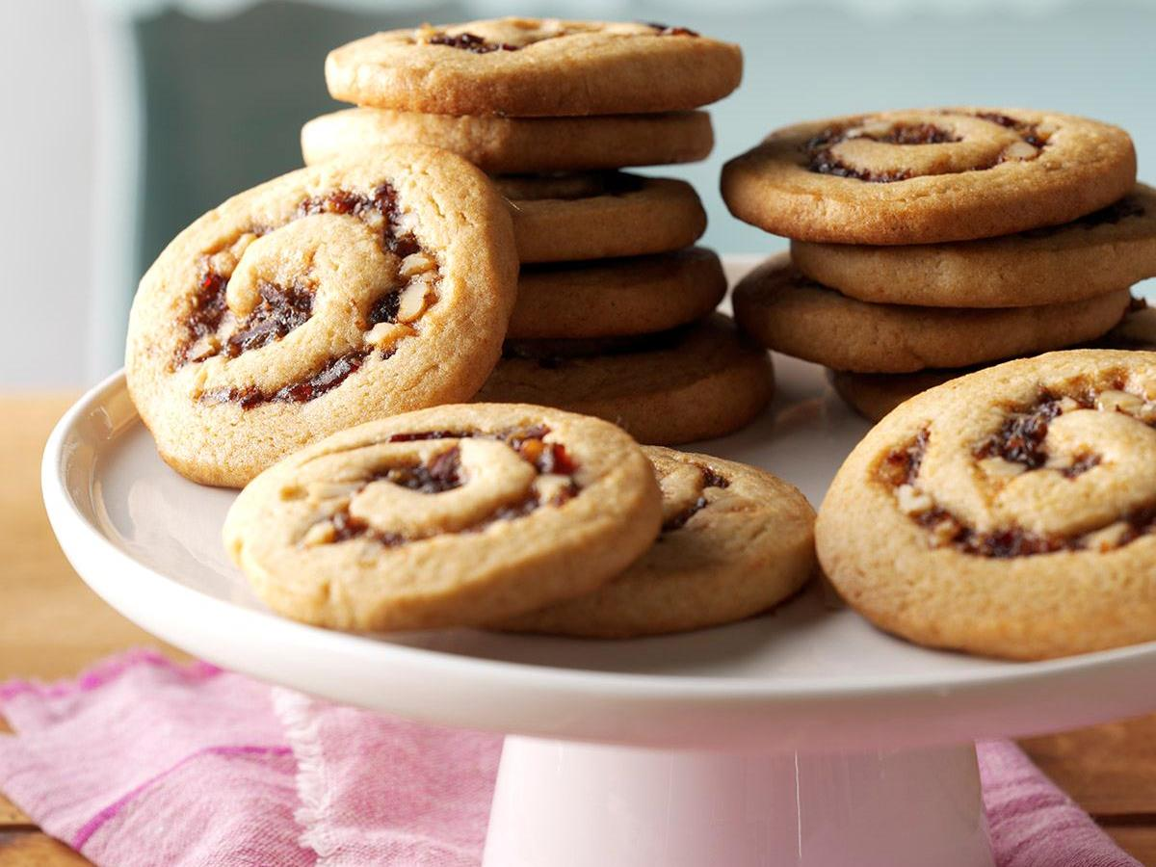

During the Holy Month, coming together as a family to prepare and share food is a wonderful opportunity to make memories that will last a lifetime. Getting ready for iftar and suhoor after a day of fasting is also a great way to involve your little ones in the rituals of Ramadan and keep them busy! Baking is especially fun to do with kids in the house and will mean you have plenty of Ramadan sweets for the family or to take as gifts to Ramadan events. To help inspire you in the kitchen, here is a delicious and kid-friendly Ramadan Cookie Recipe to try:

**Ramadan Date Cookie Recipe**

What you’ll need:

* 2 cups of flour (or gluten-free alternative)
* 1 tbsp of icing sugar
* 1 tsp of baking powder
* ¾ cup of softened butter (or dairy-free alternative)
* 2 tbsp of milk (or dairy-free alternative)
* 2 tbsp of rosewater
* 1 cup of pitted and chopped medjool dates (about 14)
* ¼ cup of water
* Pinch of salt

How to make it:

* Heat the dates, water and salt in a small saucepan and mash until you make a paste. Let it cool.
* Combine the flour, sugar and baking powder in a large bowl and then slowly mix in the butter in pieces.
* Add the milk and rosewater until it makes a dough.
* Divide the dough into 20 flat circles, place a spoonful of filling in each one and seal together to form a round cookie.
* Use a fork or toothpick to make moon or star shapes on the cookie and bake until golden at 165°C (325°F) for 25-30 minutes.
* Dust generously with icing sugar while still warm.

Baking is such a good Ramadan activity for kids, so we created this bespoke Ramadan Baking Gift Set to make sure busy parents have everything they need to start having fun in the kitchen with their little helpers. It is specially designed to get kids started in the kitchen with an apron, 6 cookie cutters and a mini hand rolling pin. It also comes with a 250ml thermal food jar so you can store the cookies safely for later, to take to school or keep warm as a gift for an iftar host!